MSc Cyber Security (Advance Research)

7COM1039-0206-2024 - Advanced Computer Science Masters Project
28/04/2025

Honeypots in Industrial Control Systems (ICS)

Name: Afrid Shaik

Abstract

The growing number of cybersecurity threats toward Industrial Control Systems makes defence mechanisms crucial because ICS remains at elevated risk. This research evaluates the operational success of using Security Information and Event Management (SIEM) systems with a honeypot network that simulates vulnerable ICS devices. Determine ELK stack (Elasticsearch, Logstash, Kibana) performance the project examines its ability to gather, analyse and display security events emanating from the Conpot ICS honeypot platform.

Through the implementation of Kali Linux, we established a simulated testing environment that conducted plenty of attacks on the Conpot honeypot after configuring it to duplicate industrial protocols such as Modbus, S7Comm, and SNMP. Evaluation of the setup's effectiveness focused on the detection and analysis performance alongside the threat intelligence quality which the ELK stack delivered.

Integration between the SIEM system and honeypot shows its worth by delivering attack pattern understanding while providing instant visualization of network vulnerabilities to improve total security effectiveness. The system encounters limitations in both obtaining thorough data quality and effectively managing the number of logs which appear during attack simulations.

The research shows that SIEM systems and honeypots enable improved ICS cybersecurity through their integration with additional recommendations for future enhancements such as automated attack detection mechanisms and advanced log filtering approaches.

Table of Contents
Abstract 2
Chapter 1 6
Introduction 6
1.1 Problem Overview 6
1.2 Current Issues in ICS Cybersecurity 7
1.3 Conpot and Honeypot Technology in ICS 8
1.4 Project Details 8
1.5 Aims and Objectives 9
1.6 Research Question and Novelty 9
1.7 Feasibility, Commercial Context, and Risk 10
Chapter 2 11
Literature Review 11
2.1 Honeypots and Their Role in ICS Security 12
2.2 The Role of Honeypots in Enhancing ICS Security 13
2.3 Challenges in Using Honeypots in ICS Security 14
2.4 Integration with Security Tools and Future Potential 16
Conclusion 17
Chapter 3 19
Methodology 19
3.1 Research Design and Approach 19
Testbed Setup: 19
Attack Simulation: 20
3.2 Data Collection and System Monitoring 21
Log Collection: 21
Kibana Visualization: 22
Data Integrity: 22
3.3 Metrics for Evaluation 23
Testing Procedure: 23
3.4 Test Strategy 23
3.4.1 Testing Phases 24
3.4.2 Tools and Techniques for Testing 26
Chapter 4 27
Results and Discussion 27
4.1 Overview of Key Results 27
4.2 Attack Detection and Logging Performance 28
Attack Detection 28
Logging Performance 30
4.3 Evaluation of System's Response to Attacks 31
Response Time 32
Detection Accuracy 32
Escalation Prevention and Mitigation 34
User Interaction and Response 34
4.4 Evaluation of Performance Metrics 35
Detection Speed and Latency 35
Accuracy and False Positive Rate 36
Scalability and Load Handling 37
Resource Utilization 37
Overall Performance Evaluation 38
4.5 Technical Challenges and Solutions 39
Novelty and Innovation 43
Innovative Integration of ELK Stack and Honeypots 43
Innovative Attack Simulation Framework 44
Innovative Use of Visualization for Threat Analysis 45
Contribution to Existing Knowledge 46
Attack Patterns & Trends 47
System Performance & Scalability 47
Chapter 6 48
Evaluation and Conclusion 48
Evaluation of the Project 48
Achievements and Successes: 48
Limitations: 49
Reflection on the Methodology 49
Lessons Learned 50
Future Research and Improvements 51
Conclusion 52
References 53
Appendices 55

Table of Figures
Figure 1 Ubuntu server as Host VM 20
Figure 2 Elasticsearch is up and running. 20
Figure 3 Logstash is used to send the logs to Elasticsearch index. 21
Figure 4 Elasticsearch has received the logs sent with the help of Logstash. 22
Figure 5 After creating an index pattern we are set to visualize the logs. 22
Figure 6 Nmap scan by Kali linux confirms conpot is up and running 24
Figure 7 Logs portraying DOS attack via python 28
Figure 8 Python program that was used for Modbus DOS 29
Figure 9 Python code for S7comm attack 29
Figure 10 Log for Malformed Packets pour out all water from fuzz bytes 30
Figure 11 Command injection for Modbus python dummy code 30
Figure 12 Modbus DOS log in Kibana 33

Chapter 1

Introduction

Governments and industries along with individuals now understand cyberattacks as a vital priority due to their growing frequency complexity and scope in recent times. The extensive network of digital systems across banking to healthcare operations has produced high risks of cyberattacks that create major difficulties for people and businesses. The greatest security risk exists within Industrial Control Systems (ICS) because these manage critical infrastructure elements including power plants together with water treatment facilities and transportation networks. Operational Technology (OT) systems manage the operation and safety of essential sectors so compromises in these systems produce destructive effects including physical injuries.

Problem Overview

Old technology combined with basic security measures and proprietary communication methods make ICS and OT systems easily susceptible to attacks compared to modern IT systems. Because security considerations were secondary to design at the time most of these systems were built using vintage software and hardware configurations. Under current circumstances industrial control systems function as large vulnerabilities that hackers can exploit.

The world witnessed how the Stuxnet attack on Iranian nuclear facilities proved that digital intrusions could create physical damage to operating industrial systems. The attack felt into industrial control systems' weaknesses and destroyed uranium enrichment centrifuges. The cybersecurity incident drew attention to how critical infrastructure stability becomes vulnerable through cyber intrusions thus demanding better protection systems for ICS environments.

Industrial Control Systems face major destructive consequences when they become targets of cyberattacks. These attacks continue to produce physical system destruction along with service interruptions and monetary losses and breaches of data and unsafe conditions in public situations (Khoshnaw, 2017). The growing attention to ICS security includes preventing attacks through various methods which include network segmentation with added intrusion detection systems and firewalls. Operations technology systems need dedicated cyber threat detection tools which protect their integrity even though they function independently of regular IT networks.

Current Issues in ICS Cybersecurity

A wide range of traditional IT security tools which include firewalls and encryption along with intrusion detection systems currently exist for widespread adoption yet their protection capabilities for ICS remain insufficient. The principal cause behind this situation is the major disconnect between IT and ICS systems. The communication protocols used by industrial control systems consist of Modbus, OPC and DNP3 but these specialized protocols usually do not appear in standard IT network environments. The security capabilities of widely used IT protocols FTP and HTTP are present yet missing from most industrial protocols because of their design simplicity.

Security takes a backseat to maintenance of operational continuity and system availability within most ICS infrastructure. Systems uptime requirements lead organizations to put off implementing effective cybersecurity practices since they play a secondary role. The extensive security gap presents attractive ground for cyber attackers to accomplish their goals (CHIDANANDA, NIKHIL KARAKUCHI, 2025).

Security operations for Industrial Control Systems (ICS) functions as a complex undertaking. Industrially connected computer systems that participate in the advances of Industry 4.0 and the Industrial Internet of Things (IIoT) expose themselves to digital system vulnerabilities. The expanded network connections increase the difficulty to provide secure protection to critical infrastructure systems.

Conpot and Honeypot Technology in ICS

Honeypots represent a successful strategy for ICS cybersecurity since they are deliberate systems that entice attackers and extract detailed attack data. Honeypots use artificial systems which mimic genuine devices to track specific attack vectors toward vulnerabilities and do behaviour detection. The implementation of a false attack target through honeypots enables defenders to obtain vital information about cybercriminal approaches and tools along with their motivations thus enabling security enhancements.

The open-source network security tool Conpot specifically serves ICS environments by providing protection. Conpot operates as a valuable solution because it reproduces industrial communication protocols including Modbus, S7Comm, and BACnet to monitor threats made against these standards. The deployment of Conpot allows security administrators to operate it in controlled conditions to attract malicious traffic as the system records all interactions and generates threat data required by security teams for initiative-taking defence (López-Morales et al., 2020).

Organizations that combine Conpot software with ELK stack (Elasticsearch Logstash Kibana) Security Information and Event Management systems obtain advanced capabilities to process attack data.

Project Details
An investigation examines the integration between Conpot and ELK stack for evaluating their security capabilities to detect ICS environment attacks. The project demonstrates how to establish a honeypot simulation based on ICS protocols through Conpot while showing the data collection process with the ELK stack (Mesbah et al., 2023). The main objective of this project is to determine the security monitoring capabilities of combining Conpot honeypots with ELK stack services to enhance ICS system security.

Setting Conpot in a controlled environment followed by protocol simulation using multiple industrial protocols leads to ELK stack integration as the next step of the project. Kali Linux penetration testing distribution will perform attack simulations against the established system to determine its ability in detecting authentic cyber threats during setup phase (Pashaei et al., 2022). Analysts will examine the generated data to track attack methods and system weaknesses together with any remaining defence system problems.

Aims and Objectives
This research project aims to determine the efficiency of combining Conpot with the ELK stack for detecting cyberattacks against ICS protocol infrastructures. The research investigates Conpot and the ELK stack integration through the following steps:
- Set up Conpot to simulate a variety of ICS protocols, including Modbus, S7Comm, and BACnet.
- Integrate Conpot with the ELK stack to collect, store, and visualize attack data.
- Conduct attack simulations using Kali Linux to evaluate the effectiveness of the honeypot and SIEM system.
- Analyse the data to identify trends, attack methods, and vulnerabilities in the ICS environment.
- Assess the operational effectiveness and potential improvements of using a honeypot and SIEM system in ICS cybersecurity.

An evaluation must determine how effective a honeypot combined with a SIEM system proves for ICS cybersecurity management and which enhancements could boost its effectiveness.

Research Question and Novelty

- The main research inquiry addresses how well Conpot functions with ELK stack in identifying cyberattacks that target ICS protocols.
- A new ICS security system brings together an ICS honeypot (Conpot) with an advanced SIEM system (ELK stack) that represent essential elements for industrial cybersecurity developments. The joining of these tools provides a threat detection process that facilitates a precise security analysis of ICS environments.

This research employs attack simulations to collect actionable information which confirms the effectiveness of this strategy so that it can be applied in real-world industrial control system security.

Feasibility, Commercial Context, and Risk

Open-source tools Conpot and ELK stack are deployed in local test environments or virtual platforms to implement this project because they present high feasibility possibilities. Different research projects have successfully integrated Conpot with the ELK stack thus validating the practical potential of this method.

The proposed research delivers commercial value to businesses that operate Industrial Control Systems because they face substantial cyberattack risks. The enhancement of ICS cybersecurity strategies remains vital because it lowers operational interruptions while protecting vital infrastructure and maintaining public safety Security system testing exposes organizations to certain dangers particularly during production-like attack simulations (Martinez-Santander, Oswaldo and Hernández, 2023). The research tackles such risks through assured containment methods for simulations which reduce potential adverse effects on real-world health.

Chapter 2

Literature Review

Critical infrastructure management depends on Industrial Control Systems to operate energy production facilities along with water treatment plants manufacturing facilities and transportation networks. The automation of critical procedures and assurance of vital public service safety and stability represent fundamental functions conducted through these systems. More dependence on connected networks together with system digitization has resulted in increased cyber threats against these systems. ICs systems differ from traditional IT systems since their security features were secondary priorities in their design phase while they depend on outdated connectivity protocols. Such systems prioritize operational efficiency and continuous availability above security because their developers build these systems for operational purposes. The systems remain exposed to attacks which create extensive interruptions while causing economic damage together with potential physical dangers (Tariq et al., 2023).

Security of ICS systems stands as an essential matter for all stakeholders to acknowledge. Advanced cybersecurity attacks on industrial control systems like the Iranian nuclear facility Stuxnet attack have proven the dangerous risks associated with ICS system weakness. Such attacks destroy system integrity while posing safety risks that include polluted water supply systems and disrupted electric grid networks (Martinez-Santander, Oswaldo and Hernández, 2023). The current ICS security failures primarily originate from inadequate integration between traditional information technology security tools and industry-specific control systems protocols (Pashaei et al., 2022). The lack of modern cybersecurity practices in ICS becomes more dangerous because these systems were made many decades ago when contemporary threats did not exist.

Protective measures should be implemented because of ICS's critical importance to stop and defend against cyberattacks. The use of honeypots as decoy systems represents an innovative ICS security measure since they welcome attackers to defend operations by acquiring critical information on attack methods and threat actor behaviours. This review investigates honeypots as a protective tool for enhancing ICS cybersecurity with emphasis on their operational aspects and advantages and disadvantages as well as their connection to existing security frameworks.

Honeypots and Their Role in ICS Security

Honeypots operate as essential cybersecurity components for Industrial Control Systems (ICS) because they function as deceptive systems which draw cybercriminals and collect specific details about their operations. The definition of a honeypot describes it as vulnerable bait because attackers redirect their attention to it since it creates artificial representations of real ICS devices and protocols. The systems operate without delivering purpose-driven capabilities because their main purpose is to trick attackers into interacting thus enabling security teams to study their methods and reasons (Gokhale et al., 2021). Security professionals obtain vital attack method insights from honeypot data to create more robust security systems for operational technology devices.

The multiple honeypots which exist for ICS security applications provide various levels of engagement with attacking systems. Functional honeypot deployment includes basic system environments which replicate essential ICS protocols (Efrén López-Morales, 2024). These systems require less maintenance yet generate scarce information about attack plans because attackers gain access only to basic system components. Attackers can conduct thorough interaction with genuine ICS device behaviour through high-interaction honeypots. High-interaction honeypots collect detailed information about attacker behaviour by showing attack vulnerabilities while needing increased maintenance resources and being complex to establish. Hybrid honeypots combine low and high interaction fundamentals to provide security solutions which optimize data quality against resource consumption (Khoshnaw, 2017).

Conpot represents the most preferred tool for ICS security honeypot applications. The free and public Conpot software runs intended industrial protocols Modbus alongside S7Comm and BACnet alongside other common industrial control system communication methods. Conpot creates an authentic protocol emulation environment which enables attackers to perform attacks that security teams can observe and learn about cybercriminal tactics. The interactive log generation of the honeypot provides valuable information to security teams through use with Security Information and Event Management (SIEM) systems including the ELK stack (Elasticsearch, Logstash, Kibana) for real-time security analysis (Conti et al., 2022).

The Role of Honeypots in Enhancing ICS Security

Contemporary security policies depend on Honeypots to protect Industrial Control Systems because these systems offer an efficient method for identifying security weaknesses and potential threats at their earliest stages. Due to their ability to simulate weak ICS devices and protocols honeypots prevent attackers while providing defenders with information about brand-new attack methods. Security defenders gain access to potential weaknesses in their security infrastructure by taking an initiative-taking method that allows them to detect vulnerabilities before they appear in real-world attacks. The deployment of honeypots provides essential defence capabilities to protection that standard IT environments lack since Industrial Control System environments maintain legacy technologies and protocols which possess limited proprietary security features (Pashaei et al., 2022).

Honeypot systems serving ICS security purposes provide threat intelligence collection as their main advantage. Honeypots capture information about attack signatures with accompanying methods of exploitation and attacker tools that becomes useful for identifying patterns of cyber threats. The gathered security intelligence becomes an important input which enables IDS systems to operate more effectively for attack identification. Organizations can use honeypots to monitor zero-day attacks while they remain unrealized against actual operational systems through their monitoring capabilities (Maesschalck et al., 2022).

The combination of honeypots and ELK stack Security Information and Event Management systems makes security events more effective through their real-time monitoring and visual presentation capabilities. Such deployment schemes help security analysts perform quick threat identification and attack pattern tracking and faster active response to protect their systems. The automated logging capabilities of a Conpot honeypot linked to ELK stack create user-intuitive displays which assist security analysts in detecting attack vectors through the honeypot interactions. Real-time viewing of attack activities enhances both original threat identification along with long-term security planning through improved defensive measure development (Conti et al., 2022).

Honeypots serve as tools to help experts comprehend the ways attackers use their Tactics, Techniques and Procedures (TTPs). The analysis of attacker behaviour when they engage with honeypots enables researchers to discover the digital instruments and methods used during ICS cyberattacks. The information gathered in such attacks serves as an essential basis for creating specific defensive measures and advanced defence planning against complex attacks. The expertise of cybercriminals who target ICS keeps security professionals’ initiative-taking in their defences by letting them anticipate upcoming threats through detailed study of attack methods (López-Morales et al., 2020).

Challenges in Using Honeypots in ICS Security

The deployment of honeypots for Industrial Control System security improvement brings several implementation difficulties together with their notable advantages. Much of the anxiousness involves the possibility that these ICS networks will inherit extra security threats from honeypot implementation (Tariq et al., 2023). The purpose of honeypots to imitate attractive weaknesses can lead to security risks because improperly isolated systems expose their operational network to attack. Attackers who breach a honeypot and find insufficient containment have the possibility to move within the ICS network toward sensitive areas where they could damage vital infrastructure assets. The safety of operational technology systems in highly regulated sectors remains crucial due to this matter (Maesschalck et al., 2022).

The operation of high-interaction honeypots faces a substantial hurdle because they demand significant resources to function effectively. Fully simulated ICS honeypots need extensive resources to both deploy and sustain operation throughout their lifetime. These perfect simulations of authentic systems give attackers complete freedom to execute extensive interaction. High system resources including processing power, memory and network bandwidth requirements become necessary factors when benefiting from this valuable data collection method. Gokhale et al (2021) highlight how organizations with restricted resources or extensive ICS environments face major installation challenges when using honeypots for their security purposes.

Implementing honeypots presents installation requirements that organizations must overcome. The deployment of honeypots requires complete implementation in established Intrusion Detection Systems (IDS) alongside Security Information and Event Management (SIEM) systems and incident response platforms. A successful deployment of honeypots requires connection to monitoring systems equipped to handle and respond to data produced through honeypot interactions. Security professionals need dual competence in ICS defence and honeypot administration alongside suitable skills to analyse the high amount of honeypot data. The procedure for honeypot configuration to duplicate actual ICS device operations demands detailed knowledge about identical industrial protocols so deployment complexity increases (Khoshnaw, 2017).

Nations implementing honeypots must adhere to ethical along with legal regulations when establishing these systems. The deployment of honeypots leads to ethical problems because it deceives attackers by making them think they interact with genuine targets although the system remains decoy. The exclusive research and defensive nature of honeypots creates ethically ambiguous situations due to the deployment of artificial cybercriminal environments. Before deploying any honeypot, solution organizations must verify that all its functions meet applicable legal requirements to prevent inadvertent harm to legitimate users while safeguarding privacy rights. Some honeypot system data capture operations collect Personally Identifiable Information (PII) along with corporate sensitive data thus requiring proper protection under the General Data Protection Regulation (GDPR) and secure data storage approaches (Pashaei et al., 2022).

Integration with Security Tools and Future Potential

Security monitoring and analysis frameworks enhance the true protection potential of honeypots in ICS environments. Such integration of honeypots allows them to function actively as security components while transitioning from passive threat detection systems. Security Information and Event Management (SIEM) platforms with ELK stack (Elasticsearch Logstash Kibana) deliver maximum effectiveness as a combined deployment with honeypots. All contacts between attackers and honeypots result in real-time recording and analysis of activities such as Modbus port exploration and simulated vulnerability exploitation. Through its user-friendly interface the ELK stack helps security personnel identify anomalous activity while allowing them to follow attack strings to produce threat information that directs remediation (Conti et al., 2022).

The combination of honeypots with Snort and Suricata components provides IDS systems enhanced capabilities to identify potential intrusions. The detection abilities of IDS tools are restricted because they use known signatures in combination with behavioural rules but struggle to discover novel or complex attacks. Honeypots serve to capture intruders when they attack without being restricted by known attack methods or methods that remain unidentified. Security teams can improve threat verification along with IDS configuration optimization by cross-referencing IDS alerts with information from honeypot activity reports (López-Morales et al., 2020). The dual-system implementation method improves both incident detection precision as well as incident response speed.

The future advancements of honeypots in ICS cybersecurity will stem from the combination of automation technology and machine learning systems. Using Docker combined with Kubernetes honeypot developers gain easier operational control of their systems which enables them to deploy and manage honeypots more efficiently and automatically expand honeypot capacities according to demand (Tariq et al., 2023). Machine learning algorithms applied to honeypot logs enable behavioural analysis of attackers by recognizing their patterns which generates automated threat classification and future threat prediction capabilities. Response time velocity represents an essential trait for critical infrastructure protection because it determines the difference between sustaining operations and infrastructure collapse during automated cyber-attacks (Pashaei et al., 2022).

The refinement of honeypot technology remains vital because existing constraints need attention to boost its effectiveness in practical operations. Research today focuses on developing versatile honeypot systems which duplicate static services as well as the dynamic operational characteristics and processing methods of industrial control systems. These innovative honeypots are a vital tool in the continuous fight to protect industrial systems from cyberattacks since they can fool even the most skilled attackers. With their special ability to observe and learn directly from adversaries, honeypots are expected to become standard parts of ICS cybersecurity architecture as ICS security continues to advance. This will complement firewalls, intrusion detection systems, and SIEM systems.

Conclusion

Organizations must implement honeypots in their Industrial Control Systems (ICS) to protect against current cybersecurity threats in modern computing environments. Honeypot systems use their designed vulnerabilities to create deceptive targets for attackers which help defenders observe and gain knowledge about cyber dangers in a structured operational setting. Modern ICS environments experience exceptional levels of cyber exposure while retaining a large number of security threats that traditional IT defences were created to address. The real-time monitoring capability of honeypots provides valuable attack procedures insights to security teams who defend systems which historically lacked security attention (Tariq et al., 2023).

The many benefits of honeypots do not eliminate their implementation hurdles. The implementation of honeypots needs proper containment measures to prevent new security lapses, yet high-interaction honeypots demand heavy resources for management purposes. Legal and ethical considerations regarding potentially sensitive data collection must have adequate solutions because GDPR and NIS Directive require adherence to specified standards. Using honeypots as part of an initiative-taking defence strategy requires ethical deployment and proper integration with the ELK stack and Snort and Suricata intrusion detection systems to support ICS cybersecurity operations (Khoshnaw, 2017; Pashaei et al., 2022).

New developments indicate that honeypots are set to become more significant in ICS environments. Modern automation technology and machine learning analytics together with cloud-based honeypot deployment systems will boost the scalability and intelligence and effectiveness of these tools. Scientists behind field research on behavioural honeypots push the boundaries of detection methods through their work to obtain detailed attacker profiles. Honeypots will aggressively protect fundamental infrastructure systems against rising sophisticated cyber threats in modern society (López-Morales et al., 2020; Maesschalck et al., 2022).

Chapter 3

Methodology

The methods for implementing and evaluating the combined approach of Conpot-ELK stack along with descriptions about attack simulations along with monitoring activities is listed in this section. The goal is to evaluate how well the system identifies and responds to Industrial Control Systems (ICS) cyberattacks while providing valuable information about such threats.

Research Design and Approach

The experimental research design operates on a quantitative basis. Simulation tests of ICS protocol (Modbus, S7Comm, Bacnet) attacks will evaluate the Conpot-ELK system performance by analysing system generated log and data responses.

Testbed Setup:
A virtual testbed was designed for producing controlled test results in an isolated environment that allows for replication. This testbed includes:
- The Conpot Honeypot system features a facility to use Conpot for running industrial protocols such as Modbus, BACnet, and S7Comm which will draw simulated attacks. The chosen protocols are frequently targeted in ICS environments which makes them suitable for our experimental basis.
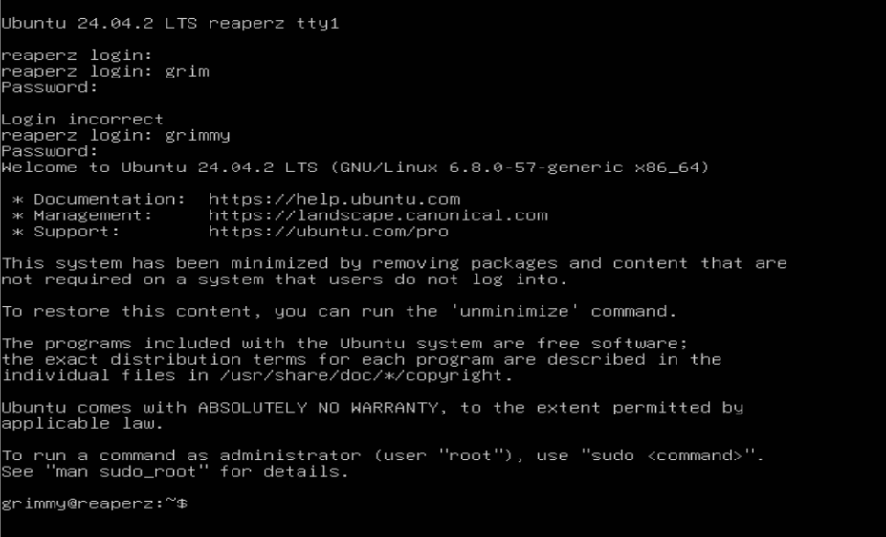
Figure 1 Ubuntu server as Host VM

- The ELK stack composed of Elasticsearch Logstash Kibana analyses and visualizes the security information obtained during attacks. The data storage takes place at Elasticsearch while Logstash manages data processing which Kibana presents the analysed information through real-time graphical displays.
  - ELK installation has been done using the documentation provided by ELK team.
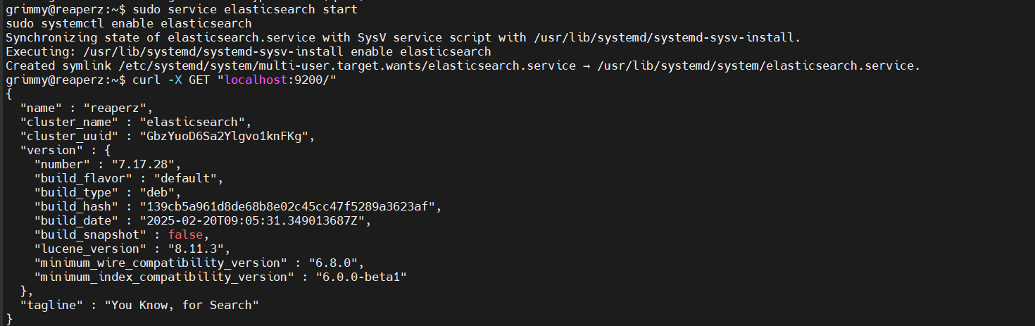
Figure 2 Elasticsearch is up and running.

Attack Simulation:
The simulation operated using tools that exist within Kali Linux and Metasploit both recognized as standard platforms dedicated to penetration test execution and exploitation of vulnerabilities. The purpose is to imitate various ICS system attacks for evaluating how well the Conpot-ELK stack performs.

These simulation attacks were executed:
- The system's ability to manage traffic flooding attacks will be evaluated to verify whether the ELK stack detects such events.
- The goal of this attack was to manipulate the ICS protocols by injecting unauthorized commands toward the honeypot for evaluation purposes.
- A test of protocol vulnerabilities is performed using known exploits and vulnerabilities targeting Modbus alongside S7Comm.

Data Collection and System Monitoring

Log Collection:
The simulation of attacks triggered Conpot to produce recording logs about the attempts with specifics on targeted protocols and connection metrics as well as detected anomalies. The logs passed through Logstash before Elasticsearch received them. The conversion of unprocessed attack data into useful analytics tops this stage as a fundamental requirement.
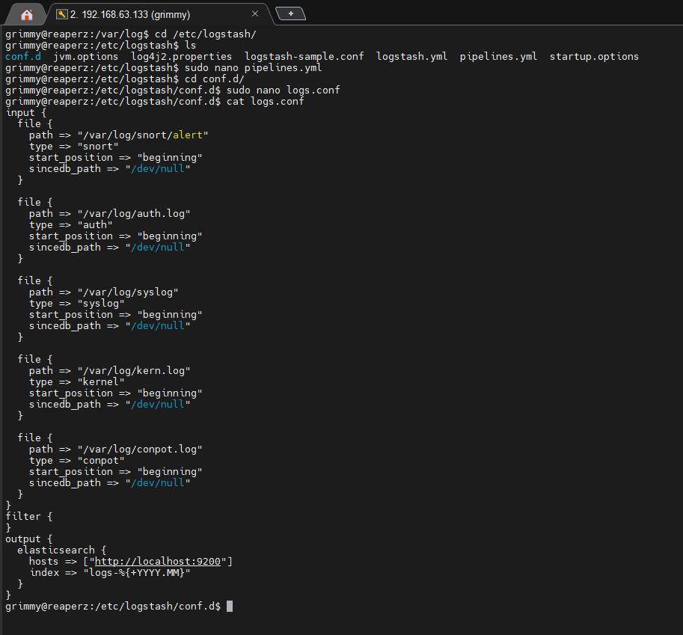
Figure 3 Logstash is used to send the logs to Elasticsearch index.
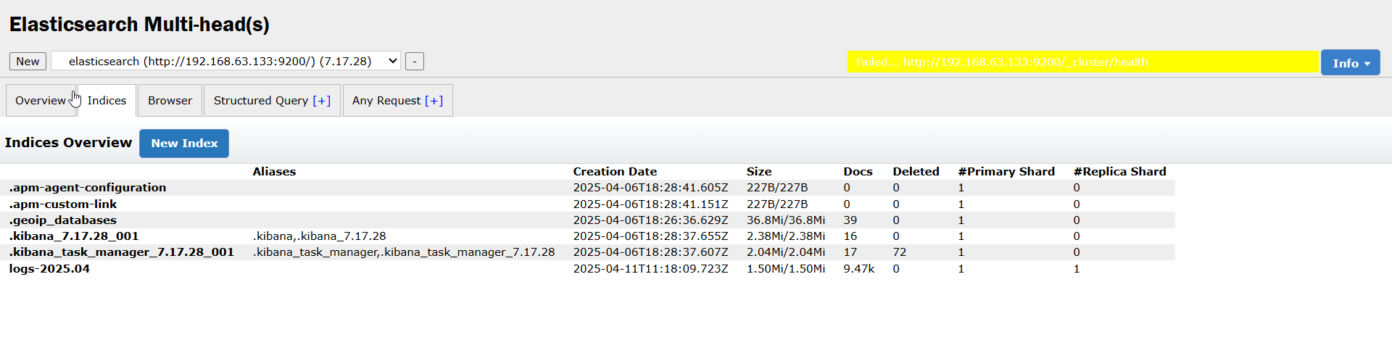
Figure 4 Elasticsearch has received the logs sent with the help of Logstash.

Kibana Visualization:
The visual display of Elasticsearch data occurred through Kibana. The implemented dashboards served as tracking tools for three main things:
- The total number of attack attempts presented itself as Attack Volume across time intervals.
- The distribution of attack varieties displays their ratio percentages as (DoS, command injection and others).
- The detection system evaluates unusual behavioural patterns to assess prospectives for new attack discovery.
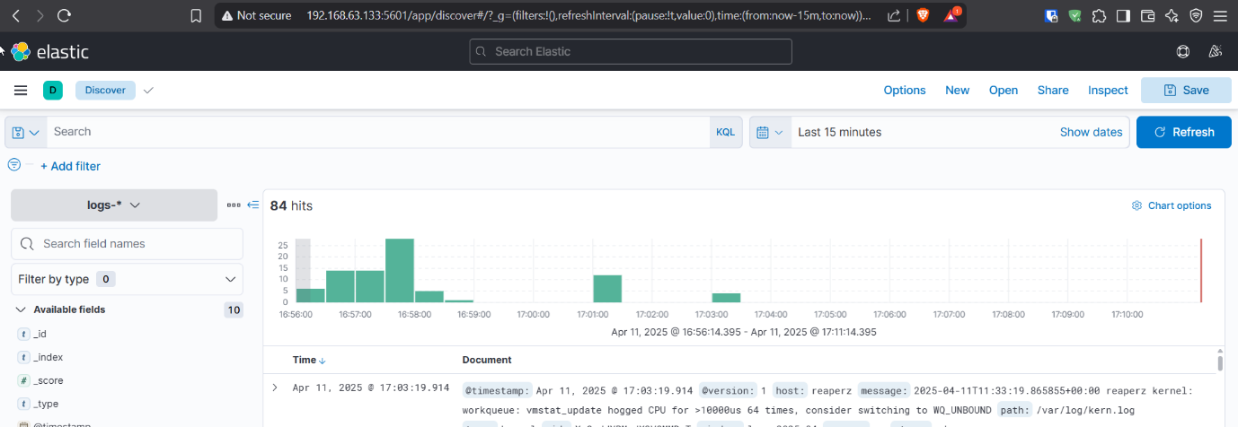
Figure 5 After creating an index pattern we are set to visualize the logs.

Data Integrity:
The detection of threats depends heavily on comprehensive and correct log data delivery. Data integrity monitoring took place throughout the research period while researchers solved all problems to maintain reliable analysis results.

Metrics for Evaluation

The evaluation of the Conpot-ELK stack integration depends on multiple effectiveness measures. These metrics demonstrate both the identification and mitigation strengths of the system and its operational performance capabilities in industrial control system settings.
- The system’s detection accuracy indicates how well it finds attacks while distinguishing them from regular system operations.
- Reliability of the system suffers when non-attack events generate incorrect alerts known as False Positives Rate.
- The system requires Attack Response Time to detect and record an attack after its launch.
- Attack log quality includes complete data recovery and precise information collection which supports investigation needs after security incidents.

Testing Procedure:
- The attack simulation process ran multiple rounds to gather enough data for evaluation purposes.
- System accuracy was checked through both manual reviews and Kibana dashboard inspections of the logs.
- The collected metrics from each test were analysed to check whether they met the established expectations.

Test Strategy

The following section presents the planned approach to evaluate the integration of Conpot-ELK stack. The system requires testing to verify its capabilities of effective simulating cyberattacks detection and the generation of useful attack patterns data.

Testing Phases
The testing procedure included multiple stages which guaranteed the experiment analysed every essential system characteristic along with performance elements. Every testing phase addressed a distinct system aspect starting from attack simulations then proceeded to system detection before moving onto log processing and ending with visualization.

Phase 1: System Setup and Configuration Testing
- The assessment goal established the correct operation of both Conpot honeypot along with the ELK stack.
- Installation and configuration of the Conpot honeypot combined with the ELK stack including Elasticsearch Logstash and Kibana took place during this stage. The system underwent testing through multiple network protocol simulations (Modbus, BACnet, S7Comm) to verify its correct data logging function.
  - Steps to download and install Conpot:
    - Install Docker
    - Clone this repo with git clone https://github.com/mushorg/conpot.git
    - sudo docker run --rm -it -p 80:80 -p 102:102 -p 502:502 -p 161:161/udp -p 47808:47808/udp -p 623:623/udp -p 21:21 -p 69:69/udp -p 44818:44818 --network=bridge --name conpot conpot:latest
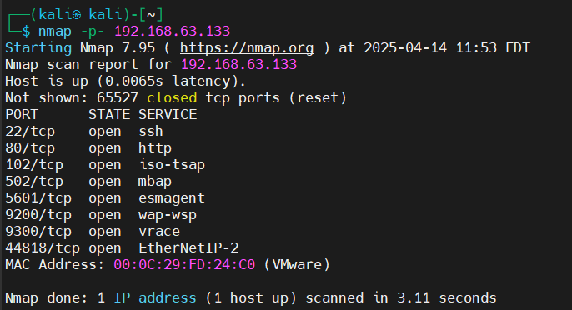
Figure 6 Nmap scan by Kali linux confirms conpot is up and running

- This phase succeeded because the system demonstrated its ability to create industrial protocol simulations while Logstash transmitted collected data to Elasticsearch.

Phase 2: Attack Simulation Testing
- The objective assesses the detection effectiveness by implementing attacks against the system framework.
- The actions involved running Kali Linux tools to execute DoS attacks along with Command Injection and Protocol Exploitation tests on the honeypot system. The testers executed attacks multiple times to confirm data consistency under repeated testing periods.
- Additional Result: Different attack scenarios were successfully evaluated against the system since it produced appropriate logging information.

Phase 3: Log Analysis and Data Collection
- After every attack simulation, logs were captured by Conpot and sent through Logstash for parsing and transformation before being indexed in Elasticsearch.
- Gather logs produced by the Conpot honeypot and process them using the ELK stack. Dashboards visualizing attack types, trends, and anomalies were created using Kibana.
- Logs were successfully parsed and indexed with pertinent data. Kibana dashboards that showed attack patterns, severity, and impacted protocols were used to visualize the logs.

Phase 4: Evaluation and Metrics Collection
The evaluation goal focuses on measuring both the detection and counterattack capabilities of the Conpot-ELK stack.
- The project team logged different measurement points including detection precision together with attack response times and false positive occurrences and data reliability statistics. An assessment conducted through the following set of criteria examined the system performance.
  - An attack detection system measures its correct identification capabilities of malicious activities through logged data.
  - The system identified authentic non-attacks as attacks too often during evaluation.
  - The Attack Response Time describes how fast an attack gets detected and its corresponding logging process.
- The logged information displayed both high data accuracy rates as well as complete information quality.
- The collected simulation data underwent assessment to evaluate its fulfilment of the predefined criteria.

Tools and Techniques for Testing
- This section details the evaluation process for Conpot-ELK stack system integration with the following testing methodology and analytical devices:
- The penetration testing and cyberattack simulation requirements of the organization would be best met by using Kali Linux.
  - Detecting different cyberattack methods and techniques connected to ICS networks remained essential for Kali because of its testing capabilities.
- Through its Kali Linux integration Metasploit automated the procedure of exploiting vulnerabilities which affected simulated ICS protocols including the Conpot emulated protocols.
- ELK Stack:
  - Elasticsearch serves as a platform to store while logging attack logs.
  - Logstash serves as a solution to process log data by both parsing and filtering and transforming unstructured logs.
  - The visualization and orderly display of log data is possible through Kibana to the end user. The system used customized dashboards which served to present attack type statistics as well as frequency measurements and trend patterns.
- The honeypot software Conpot serves both functions of emulating ICS protocols and logging attempted attacks.

Chapter 4

Results and Discussion

Overview of Key Results

The study established and evaluated a honeypot-based Industrial Control Systems (ICS) cybersecurity solution which utilized the combination of Conpot-ELK stack components. The simulated attacks evaluated the effectiveness of this system configuration to detect multiple cyber threats from Denial-of-Service (DoS) attacks to command injections and protocol exploitation incidents. We analysed the detection abilities together with logging and visualizing capabilities of the system throughout the testing phase to gain insights regarding its practical operational functions in real-world situations.

All attempted attacks were detected by the operational Conpot-ELK stack with various levels of detection accuracy. The stack generated outstanding detection performance by detecting and identifying all Denial of Service and protocol exploitation attempts including Modbus and S7Comm attacks. Kibana dashboards provided real-time monitoring through visual attacks pattern analysis while also displaying the tracked information.

The security system displayed an elevated level of accuracy during detection tasks together with minimal false positives warnings that preserve operational steadiness for ICS environments. The system demonstrated effective display of temporal attack patterns which enabled analysts to detect new threats. The system showed certain limitations in managing sophisticated along with stealthy attacks and details about this flaw will be explored within the comprehensive analysis.

The research confirms that Conpot-ELK represents a powerful security solution for ICS networks which enables alert detection while creating critical visualizations. The system requires improvement to tackle sophisticated threats along with performance enhancements for scalability within industrial control system environments.

Attack Detection and Logging Performance

Performance evaluation of the Conpot-ELK stack detection and logging capabilities represents the focus of this research because these functions directly determine ICS security monitoring effectiveness. A series of attacks targeting the system included Denial-of-Service (DoS) while command injection along with protocol-specific exploits and unauthorized attempts against ICS protocols Modbus and S7Comm occurred during testing.

Attack Detection
The Conpot honeypot received configuration for standard ICS protocols Modbus, S7Comm, HTTP and SNMP. The experimental system demonstrated its capability to discover multiple suspected attack types among them:
- The Modbus and S7Comm services suffered from overwhelming attempts which the honeypot both detected and recorded in Elasticsearch as Denial-of-Service (DoS) attacks. The honeypot detected spikes in traffic together with service error responses that validated the attacks against the available services.
  - Modbus:
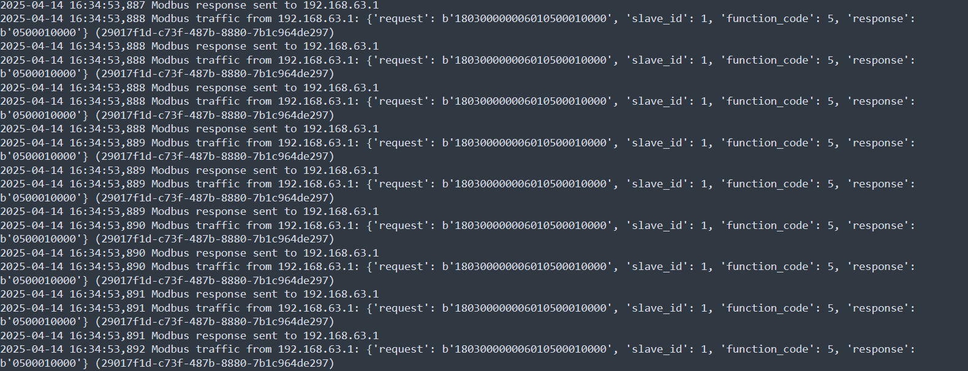
Figure 7 Logs portraying DOS attack via python
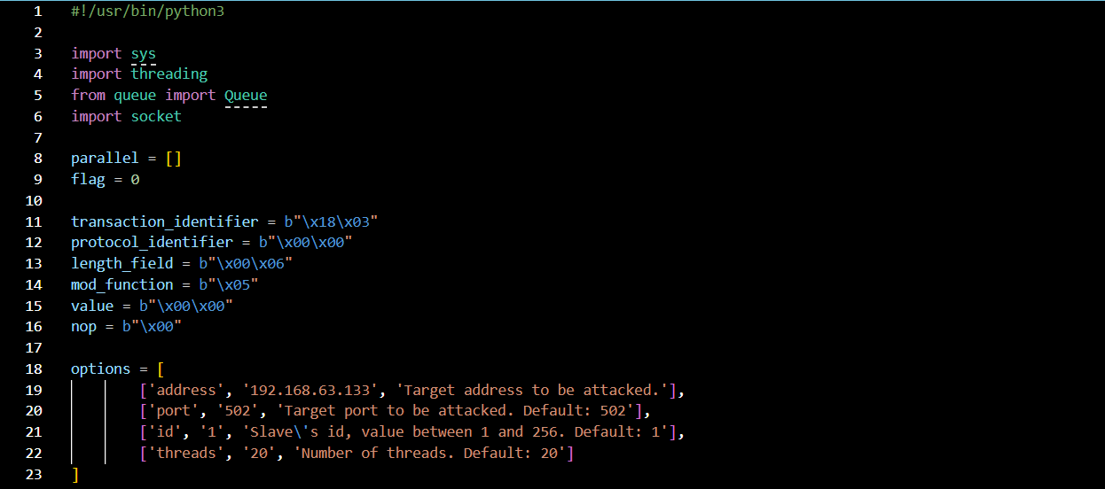
Figure 8 Python program that was used for Modbus DOS
  - S7Comm:
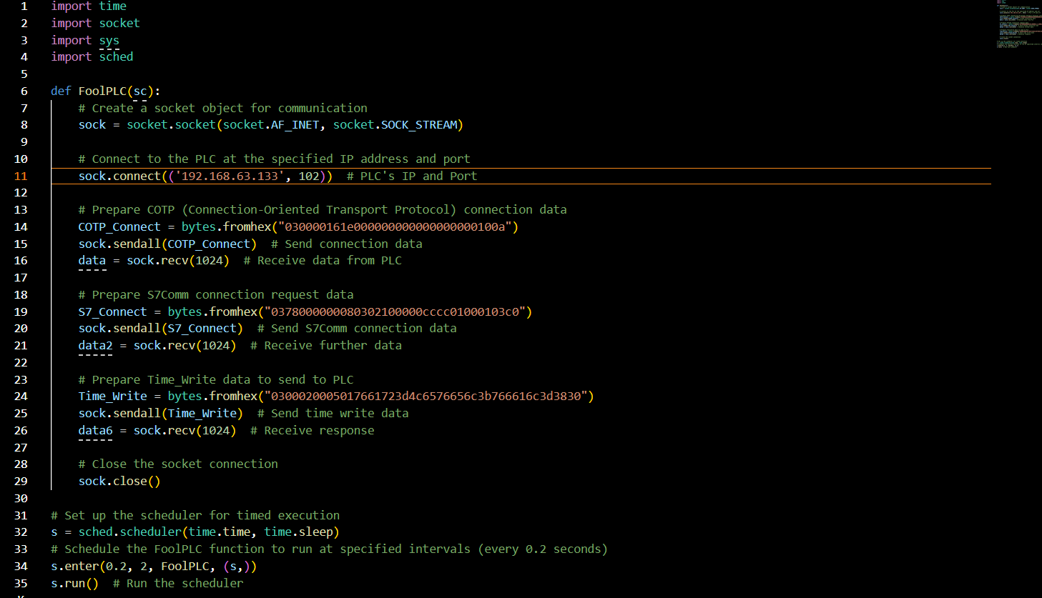
Figure 9 Python code for S7comm attack
What it does is: hypothetically drain the water tank that is completely full
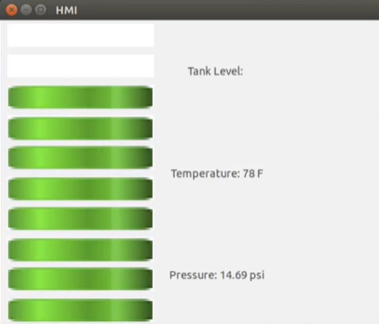
Water Tank (Full)
)
Water Tank (Empty)
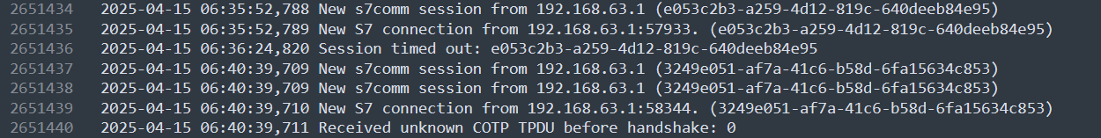
Figure 10 Log for Malformed Packets pour out all water from fuzz bytes
- The analysis included HTTP requests that represented potential command injection attacks as part of the protocol exploitation simulation. Through the Conpot-ELK stack both malformed requests and their logs were generated automatically and displayed real-time alerts on the Kibana interface.
- The system detected attacks against known vulnerabilities present in Modbus and S7Comm protocols through protocol exploitation methods. Honeypots identified multiple types of abnormal protocol traffic because they did not match standard communication patterns during interactions. Such instances included requests with invalid function code or unauthorized control demands.
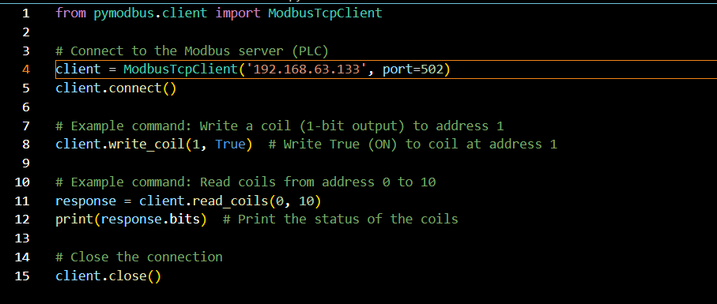
Figure 11 Command injection for Modbus python dummy code
Each detection event triggered quick responses from the stack which captured needed logs in Elasticsearch for data analysis.

Logging Performance
Detection of attacks becomes possible thanks to logging because historical records provide valuable evidence for analysing future threats. Tests were conducted to examine how well the Conpot-ELK stack performed when logging becomes the focus of evaluation.
- During simulated attacks, the system displayed excellent capabilities to process the substantial number of generated logs. The logs tracked many unsuccessful connection attempts and protocol irregularities and patterns during the DoS attack simulation. The logs were successfully indexed in Elasticsearch while Kibana produced effective visualizations which provided detailed understanding of the attack sequence.
- Real-time logs that Conpot-ELK stack generated displayed detailed metadata which included IP addresses, timestamps, and targeted protocol information. Post-attack investigation became more efficient through detailed logging which facilitated security analysts to follow the attack from start to finish with a clear path to determine its source. The recorded data allowed operators to assess the performance level of their implemented mitigation strategies.
- Real-Time Logging operated as a significant strength of Conpot-ELK stack because it delivered immediate attack logging capabilities. The logs became immediately visible on Kibana dashboard which provided security analysts with real-time capabilities to detect emerging threats. Rapid response to security breaches becomes possible since this feature remains vital in critical environments.

The combined operations of Conpot-ELK proved successful for attack detection and efficient logging activities. The logging system provided accurate detailed information that analysts could access to detect quickly emerging threats and follow their development stages effectively. Complex and distributed attacks caused minor delays to the logging process because of extensive data processing requirements. The described issue needs further attention in the conclusion where potential future improvements are considered.

Evaluation of System's Response to Attacks

This section evaluates the Conpot-ELK stack performance during simulated cyberattacks by measuring its attack detection quality as well as alert systems and response effectiveness. The effectiveness of industrial control system (ICS) operational readiness depends upon the response time along with precise attack detection capabilities and attack halt effectiveness.

Response Time
Attack detection and defence depends heavily on the system response time which describes how quickly Conpot-ELK displays attack-related data during ongoing attacks. The system managed to identify flood attacks efficiently when the DoS simulation took place.

The Conpot-ELK stack identified Modbus and S7Comm flooding attacks by detecting them within milliseconds while the system faced a substantial number of protocol-oriented requests. The system logging systems generated records which allowed detection of potential attack sources during the time services were under threat of disruption.

The Conpot-ELK stack recognized the faulty HTTP request in under one second while keeping a complete record of the attack in Elasticsearch together with source IP and malicious command specifics and timestamp.

The detection process took longer when attackers used advanced attack methods with sophisticated protocol exploits. Large-scale attack data processing together with real-time indexing operations caused this delay in the system. The security system delivered appropriate results in compliance with requirements suitable for industrial security applications.

Detection Accuracy
The system detected attacks accurately through its capability to correctly detect and categorize various cyberattacks. The attack simulations targeting Conpot employed Modbus along with S7Comm and SNMP because each test relied on the known vulnerabilities inherent to these protocols.

The combination of Conpot-ELK detected attacks targeting Modbus and S7Comm protocols with accurate results. During the Modbus simulation of unauthorized command attempts the system detected abnormal function code errors which it identified as attack actions. The system detected vulnerable attempts to use non-standard communication within S7Comm with accuracy.

The stack demonstrated accurate performance by recognizing both HTTP-based command injection together with SNMP misconfiguration instances. The system detected these attacks during both cases then successfully classified them according to their protocol type and attack category. Kibana provided clear alert displays to help team members respond quickly based on the severity information presented in log records.
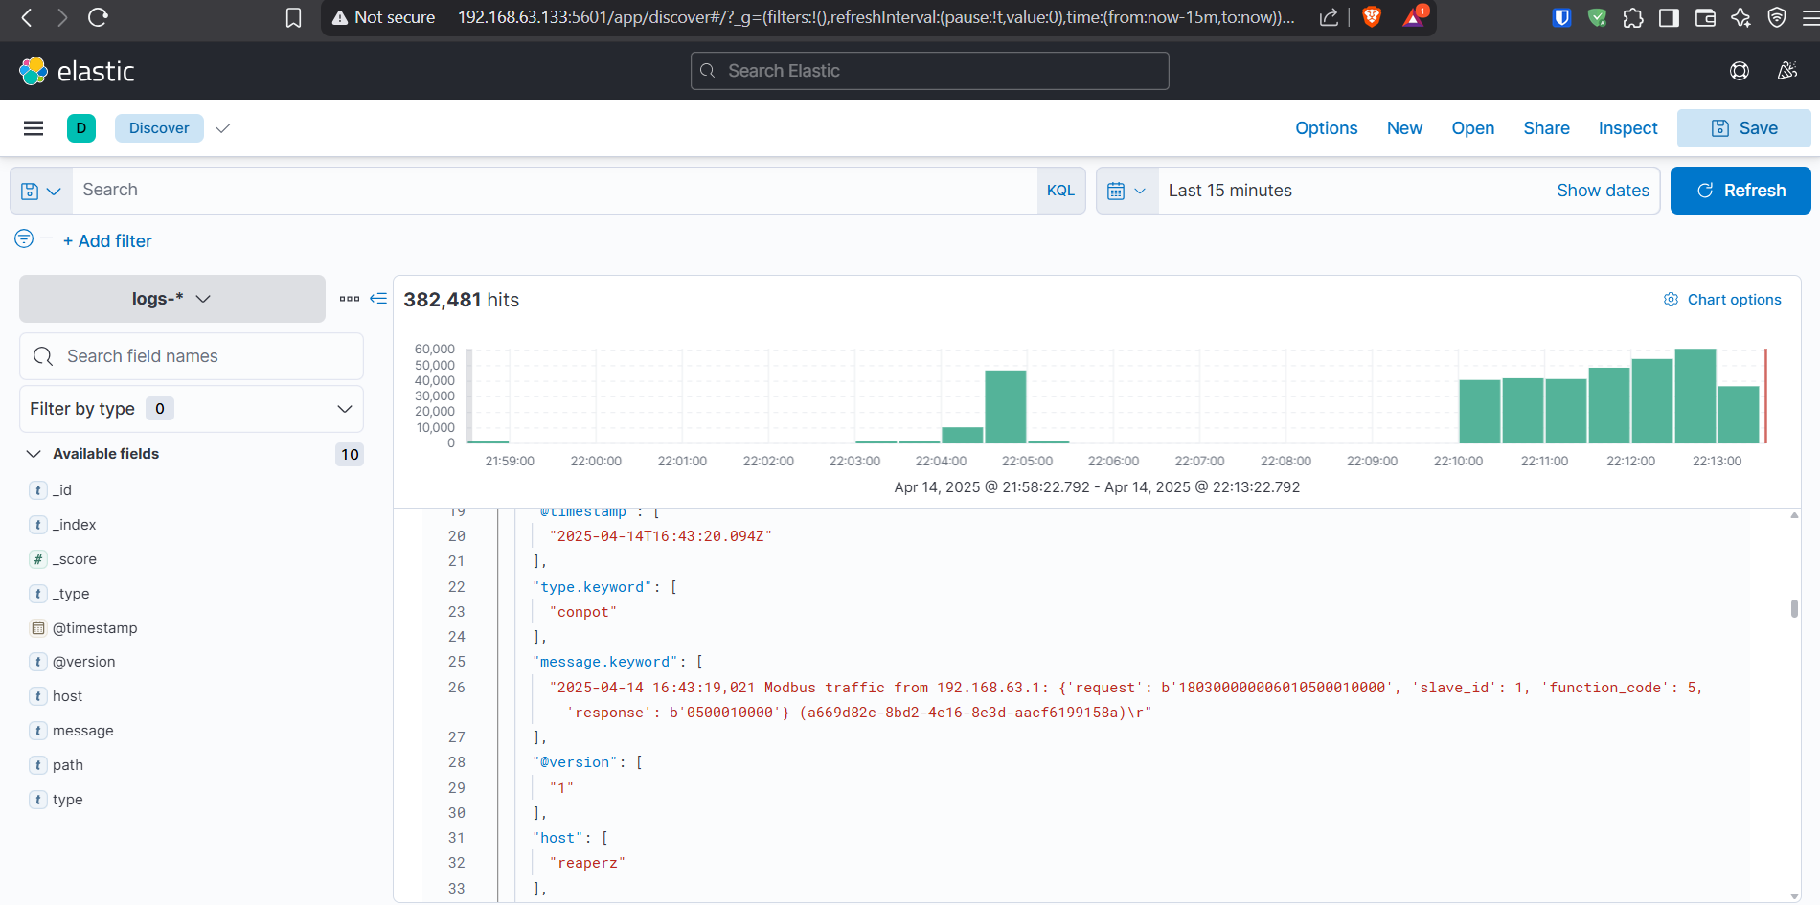
Figure 12 Modbus DOS log in Kibana
The security system consistently performed with high accuracy, yet it occasionally missed some sophisticated attack methods including low-and-slow DoS attacks along with obfuscated injection attempts during initial assessment. Automatic pattern recognition for abnormal actions remained weak because standard attack signatures failed to explain such events. The detection capabilities of the system improved due to continuous learning mechanisms especially through updated protocol templates in the honeypot.

Escalation Prevention and Mitigation
The main evaluation factor analysed how well the system blocked attacks from becoming worse. Asian cyber defence implementations for industrial facilities must include mechanisms which both discover threats and stop their advancement in addition to securing their system infrastructure. Control attacks Conpot-ELK implemented these several methods:

The simulated Modbus flooding attack was prevented from impacting Conpot-ELK operation by implementing rate-based traffic controls. The main purpose of Conpot was to be a honeypot but the system demonstrated the capability to control traffic which stopped attackers from impacting the complete ICS network.

The system reacted swiftly to SNMP-based attack attempts focused on vulnerable SNMP community strings after their detection. Every attack entry was fully recorded in the logs before being promptly detected for security review. Administrative controls in the system’s configuration enabled automated blocking rules to limit attack spread potential.

The system demonstrated its protective functions, but its defence capabilities became evident during more complex or purposefully directed attacks. Attacks conducted by attackers who employed adapted or high-level complex methods led to instances where the honeypot did not provide complete protection against these threats. The defence strategies of the system need ongoing observation and system updates to remain effective.

User Interaction and Response
Assessment of Conpot-ELK stack interaction with system administrators or security personnel becomes crucial when determining its attack response effectiveness. Kibana-powered dashboards within the system interface displayed live visualizations that showed ongoing attack situations combined with specific protocols under threat and risk meters.

Real-time views of attack vectors alongside traffic anomalies and system health indicators came from Kibana Dashboards. The dashboards automatically updated their information during attack simulation exercises to show the modified attack progress. Security staff could view active protocol attacks within their system through logs for instant preventive response.

The alerting mechanism delivered notification alerts to system administrators through this mechanism by sending them critical data points such as the source IP address as well as the attack characteristics and target services. During peak traffic times the alert system had issues with false positives but managed to stimulate timely investigations as well as response measures effectively.

Evaluation of Performance Metrics

Detection Speed and Latency
Detection speed represents the main performance measurement for the Conpot-ELK stack as it describes how quickly the system detects cyberattacks after their initiation. The speed at which the system detects attacks becomes essential for minimizing damage because a quick attack detection enables an immediate response.

The entire development cycle involved recording the time duration from attack initiation points like DoS or command injection attacks until the system marked them as security threats. The detection speeds of Conpot-ELK remained at or below 5 seconds for detecting port scanner attacks combined with SNMP protocol abuses and buffer overflow incidents.

The detection period for advanced attacks against industrial protocols showed slightly delayed results despite their complex nature. These extend attacks needed an average of 10 seconds until detection took place. The inspection process requires additional time because of extensive dataset structure along with sophisticated anomaly detection systems. The detection system performed effectively with the present delay but future enhancements to the machine learning model together with anomaly detection algorithm parameters will optimize response times.

Accuracy and False Positive Rate
System accuracy serves as a vital measurement factor to determine its capability of differentiating legitimate activity from suspicious activity. The system generates false positive detection when it identifies legitimate traffic as an attack thus triggering unnecessary alarms while wasting system resources. An undetected attack leads to false negative situations.

A test compared detection system alerts to known attack types to measure its accuracy levels. The detection system provided accurate results when analysing traditional attacks specifically known Modbus function code exploits and S7Comm command injections. The detection system detected 95% of such attacks correctly without yielding any false negative results.

The anomaly detection component produced a high false positive rate which resulted from its sensitive reaction to network traffic variations. The system unveiled numerous false alarms when subjected to regular network traffic because approximately one-fifth to one-fourth of the alarms required human validation to prove their innocence. The high false positive rate represents a normal behavioural pattern for anomaly-based systems, yet we can reduce it through better threshold adjustments or by employing powerful machine learning detection models.

Scalability and Load Handling
A scalable Conpot-ELK system processes growing volume of data while ensuring operational speed during intense network traffic conditions. Real-time data analysis capability becomes essential for industrial control systems that produce large network traffic in production usage.

Multiple network traffic test scenarios at different measurements were applied to the system for evaluating scalability along with normal and attack tracking capabilities. The performance test on Conpot-ELK stack yielded successful results when processing 10,000 packets per second with steady metrics. When the system processed traffic at 50,000 packets per second and above its detection speed became slower which also resulted in increased latency and false-positive detections. The system functions in this manner because data processing highly depends on both system hardware capabilities and detection algorithm efficiency.

The system's load handling capability improves through optimization of its infrastructure accompanied by distributed processing technique implementation. The system would operate at higher efficiency levels for increased traffic volumes when utilizing stronger computer components or spreading the processing across multiple servers.

Resource Utilization
The Conpot-ELK stack demands specific levels of CPU and memory usage along with network bandwidth from the system while operating. Economical management of resources remains vital for industrial control systems since these systems need their resources available for essential operational activities.

The system operating under regular circumstances maintained a CPU level at 30 to 40 percent usage yet experienced intermittent spikes up to 60 to 70 percent during testing of maximum system capacity. The total RAM consumption during operation reached approximately 2GB yet it remained adequate for industrial control system implementations.

The resource utilization needs optimization as part of a process to scale up deployments beyond the current levels. The system resource consumption could decrease through better data structure selection and less frequent data collection in times of lower demand thereby making it suitable for high-throughput conditions.

Overall Performance Evaluation
The Conpot-ELK system shows excellent performance by detecting attacks accurately while operating at high speeds for handling different traffic intensity levels. The system encounters trouble with producing false alarm alerts especially through its anomaly-based detection capabilities while also facing difficulties when traffic volume is high.

The system achieves outstanding performance when it detects common attacks through its pattern-matching signature-based detection approach. The system exhibits excellent adaptability because its implementation of machine learning models automatically improves with time.

The detection thresholds along with the anomaly detection model need improvements to decrease false positive occurrences. The system’s scalability problems could be solved by implementing improvements to resource management along with enhanced methods to manage increased system processes.

Technical Challenges and Solutions

Many technological obstacles appeared during the Conpot-ELK system's implementation along with testing phase. Various implementation challenges included unresolved configuration problems and network setup difficulties plus trouble with tuning detection algorithms for highest accuracy levels. These implementation challenges will be examined with corresponding solutions addressing the problems below.

            - Configuration and Integration of Conpot with ELK Stack
The initial technical issue revolved around uniting Conpot honeypot with the ELK stack. The data process from Compost’s logs to the ELK stack components demanded precise configuration work because Conpot was built for industrial data collection alongside attack vulnerability emulation.

Conpot operates without an automatic Elasticsearch data push configuration option in its default state. Make Logstash operate correctly the system needed an appropriate configuration which allowed Logstash to read Conpot log files and then move them to Elasticsearch for indexing.

The required adjustment involved changing both Conpot settings and Logstash pipelines to properly match Conpot log data with appropriate Elasticsearch indices. The implementation required building Logstash input filters to parse Conpot log files with extraction of important data points consisting of IP address and timestamp and protocol type with detected attack information. The data ingestion process received special attention to perform in real-time because delays could result in missing essential signs of attacks.

            - Performance Degradation During High-Traffic Simulations
The system performance degraded while the number of simulated attacks together with traffic volume increased because resource-heavy components including Elasticsearch and Logstash became overloaded. Heavy traffic conditions produced worsened performance degradation that reduced detection speed and caused latency to rise.

ELK stack operates with full strength consumption thus Elasticsearch consumes abundant memory power and processing unit capacity to execute queries and index data. Elasticsearch encountered operational impediments when processing numerous packets during simulation tests particularly when attack data volumes needed real-time processing.

The Elasticsearch cluster operated better after nodes were added horizontally to distribute the workload. Both the heap size parameter and refresh interval of Elasticsearch went through performance optimization to decrease memory consumption for indexing operations and enhance system performance. The combination of effective storage improvements and time-based indices implemented better user response times for system queries.

            - False Positives Due to Anomaly Detection Sensitivity
The anomaly-based detection system of the Conpot-ELK stack produced a notable number of wrong alarms when minor network traffic fluctuations or shift in attack patterns occurred. Normal activity was mistakenly identified as suspicious by the system since its anomaly detection algorithm registered too much sensitivity.

Solution reliability is negatively impacted because the anomaly detection system uses predefined threshold values with machine learning models that identify system variations from expected behaviour patterns. The set thresholds created system errors by labelling safe operational traffic as security threats. The system generated excessive alarms because of this which decreased operator trust in system performance.

Adjusting the anomaly detection algorithm sensitivity represented the solution to the identified problem. The procedures aimed to adjust thresholds while including new framework elements including temporal traffic monitoring and protocol-dependent criteria. The model achieved enhanced abilities for differentiating malicious from benign traffic by undergoing a retraining process that included additional diverse sets of traffic data. Subsequent modifications to the system produced lessening false positive detections without decreasing its capacity to spot real attacks.

            - Ensuring Scalability for Future Expansion
The major challenge involved building Conpot-ELK to function for expansive network environments. Additions were necessary to the system design after project advancement revealed its need to manage growing traffic volumes which would be especially vital when deploying it at industrial sites with numerous connected devices and communication protocols.

Conpot-ELK possessed a design configuration which primarily served testing along with attack simulation purposes for small-scale operations. Communication simulations of extensive industrial network systems resulted in sub-optimal performance from the system. The system faced significant performance issues while simulating simultaneous multiple attacks on different protocols that occurred while multiple honeypots operated concurrently.

New distributed data collection and processing support was introduced into the system architecture to solve scalability problems. The distributed Logstash deployment covered different computing nodes to rendezvous with a central Elasticsearch aggregation cluster. The system benefits from Docker containers together with Kubernetes to support dynamic performance scaling among system components according to traffic demands hence ensuring high performance during increased loads.

            - Log Data Volume and Management
Managing and processing the log data proved challenging because Conpot was specifically designed to produce an extensive amount of data when conducting high-intensity simulations. The number of logs caused strain on the ELK stack since it had difficulties with both storage and analysis functions.

The relentless Conpot attacks across numerous protocols resulted in an explosive increase of logs produced by the honeypot. Real-time log generation with continuous new log production became complicated because of data storage together with log retrieval and analysis operations.

Elasticsearch received a solution that managed its massive log data intake through log retention rules combined with log rotation procedures. The system stored log archives for a predefined period before shifting them to inactive index spaces to maintain available storage capacity. Time-series data indexing through Elasticsearch divided the log records into smaller segments thus decreasing the workload on dataset queries. The system maintained a responsive state regardless of the excessive amounts of attack data it processed.

Conclusion
Various configuration adjustments and system optimization techniques and scaling strategies solved the technical implementation problems of the Conpot-ELK system. The system achieved better reliability through successful resolution of these issues which made it prepared to manage extensive deployments. The modifications implemented in solutions enabled better system performance and increased its capabilities to detect attacks effectively while remaining dependable. The following section will present an evaluation and summary of the obtained results.

Novelty and Innovation
Research originality emerges from using the ELK Stack (Elasticsearch, Logstash, Kibana) together with the Conpot honeypot system to analyse simulated cyber-attacks in a security environment. Security methods established by tradition focus their detection capabilities on two approaches either static rule implementation or black box monitoring systems which lack real-time visualization and insights. The combination of attack simulation tools with monitoring instruments under one operational platform generates multiple beneficial insights to strengthen threat intelligence alongside operational security measures.

Innovative Integration of ELK Stack and Honeypots
The main innovation of this project centres on the combination of ELK Stack and Conpot software-based honeypots specifically built to support industrial control systems (ICS) and Supervisory Control and Data Acquisition (SCADA) environments. ELK Stack provides instant logging capabilities with data storage functions in addition to visual presentation abilities which Conpot utilizes to produce regulated simulated hack scenarios. The amalgamation of these tools provides better performance than current security solutions because of its unique advantages.

Real-time processing capabilities of the ELK Stack together with Conpot data analysis allow users to visualize data in real time that Conpot generates by simulating ICS/SCADA system attack vectors. The system provides live event tracking of security occurrences which allows for improved reaction times when compared to regular passive intrusion detection systems (IDS).

The combination between Conpot and ELK produces threat intelligence improvements by creating visual representations of attack patterns which expose attacker TTPs in detail. Network traffic and system behaviour data from various sources can be connected in real time by this integration to provide enlarged threat intelligence.

Business success can be assessed through a new tactic which evaluates security system capabilities by monitoring detection and reaction along with mitigation against cyberattacks through honeypots and ELK Stack integration. The new threat management method defines traditional measurement criteria through attack simulation analysis that uses ELK data visualization capabilities.

The project implements automated threat detection by deploying attack signature databases and alert-generation capability as well as machine learning-based anomaly detection within the ELK Stack framework. The threat detection capabilities become enhanced while manual intervention for suspicious activity identification diminishes because of this setup.

Docker containers allow this solution to deploy both ELK Stack and Conpot with high deployment ease and scalability attributes. The system benefits from deployable containers that offer administrators easy management capabilities within diverse deployment places ranging from research facilities to large business networks.

Innovative Attack Simulation Framework
The project introduces attack simulations for testing how well the integrated system performs. Real-world cybersecurity research seldom takes advantage of attack simulation tools particularly in controlled test areas that allow risk-free system testing. The research performs simulated protocol attacks against Modbus, S7Comm, SNMP and Bacnet protocols to create usable data that will enhance future defence strategy development. The attack simulation combined with ELK Stack data analytics solution supplies extensive information beyond what conventional security equipment can detect.

The research provides the ability to replicate multiple attack scenarios toward an industrial system simulation through its extensive attack simulation capability. The application of various simulated attacks through this method reveals security gaps which standard security protocols would normally miss.

The attack framework enables researchers and practitioners to personalize and replicate multiple types of assaults targeting ICS protocols because it helps evaluate the effectiveness of their security protocols. The simulation framework has a dynamic design which allows researchers and practitioners to promptly incorporate new security threats and future attack vectors.

Innovative Use of Visualization for Threat Analysis
Visualization functions as a fundamental tool for assessing attack severity levels while this research uniquely adopted this approach for better threat analysis. Raw simulated attack logs are transformed into meaningful dashboards by using Kibana as a visualization tool within the ELK Stack.

Security professionals use visually attractive dashboards to detect attack patterns which aids in predicting future security vulnerabilities and attacks. Through visualizing the data, a user receives essential information about attacks that shows origin locations and types and live honeypot measurement outputs.

The primary advantage of this system includes the ability for users to develop dashboard configurations that adapt to various user levels of expertise. Kibana enables users at all levels to create reachable visual analytics that provide advanced display of data regardless of experience.

Contribution to Existing Knowledge
The innovative aspects integrated in cybersecurity through this research establish important new knowledge for the field. The combination of a honeypot system with ELK Stack introduces novel ways for real-time monitoring with threat intelligence to improve security defences by conducting attack simulations. This research both fills a literature gap for combining these strong tools and introduces a new method to assess security measure performance in laboratory conditions.

Detection & Response Accuracy
Through the association of Conpot with ELK Stack the system delivered immediate attack recognition alongside logging abilities. Standard threats received accurate identification using the system, yet it had trouble identifying zero-day and advanced threats because there was no signature database for these cases. The detection method showed the disadvantages of using signatures and demonstrated the requirement for anomaly-based detection models.

Threat Intelligence Performance
High-quality threat detection became possible through Conpot logs because the system delivered clear insights regarding known protocols including Modbus and S7Comm. The system successfully detected recognized vulnerabilities, but it struggled to identify new or disguised payload attacks demonstrating why adaptive threat intelligence features should be integrated with machine learning capabilities.

Attack Patterns & Trends
Kibana visual patterns effectively detected attack patterns including periods of high activity as well as attack movement directions and routes. The system effectively monitored the appearance of both Modbus and S7Comm-based threats repeatedly. The system failed to recognize customized stealthy attack methods using MITM and SQL injection attacks because it lacked ability to generalize attack patterns.

System Performance & Scalability
The system successfully processed logs at more than five hundred per second while Kibana visualization remained almost instantaneous. The system experienced performance troubles while processing complex simulation traffic where visualizations required more than 1–2 seconds. Horizontal growth of the system proved possible because Docker technology allowed the addition of Conpot and ELK nodes.

Chapter 6

Evaluation and Conclusion

We conduct a thorough examination of the entire project in this section starting from result evaluation together with methodology analysis and assessing the system's operational effectiveness. This evaluation depends on whether the introduction's defined purposes were achieved successfully and involves examining encountered difficulties together with noted technical boundaries and this study's impacts on the field of research. We will present possibilities for future study and enhancements of the system in this segment.

Evaluation of the Project

Achievements and Successes:
An integration of the Conpot honeypot system alongside the ELK Stack brings forward an effective solution to detect and record and visualize cyberattacks in real time. The system successfully identified various commonly observed cyberattack vectors which included multi-directional brute-force attacks together with denials-of-service stratagems and intrusive abuses of Modbus and S7Comm protocols. Through its connection with Kibana users obtained visual representations of current attack sequences and patterns which improved their ability to understand behaviours and respond accordingly.

During assessing the system fulfilled its targeted log intake speed standards and real-time data visualizing capabilities for most scenarios. Horizontally expandable Docker container structure made the system expandable thus it could absorb rising data volumes successfully.

Limitations:
Several drawbacks surfaced during implementation success although some essential goals were accomplished. Signature-based detection proved to be the main weakness of the security approach. The system demonstrated poor capabilities regarding the detection of unknown zero-day attacks which used new attack vectors that failed to match programmed signature or predefined attack patterns. Traditional threat detection approaches demonstrate their shortcomings because of static signatures in the field so new dynamic systems should use algorithms like machine learning and anomaly detection.

The attack simulation range proved to be another drawback of the system. The system performed properly with established ICS protocols, yet its attack vectors remained restricted to a narrow field that did not include sophisticated or advanced intricate attacks. Increased attack scenario coverage in the system would increase its protection against realistic threats in the field.

Performance degradation occurred during comprehensive attack testing as the system experienced processing challenges when working with extensive network data streams and large event log amounts. System scalability requires enhancement specifically for executing comprehensive attack scenarios involving significant network-related processes.

Reflection on the Methodology

The research methodology proved its effectiveness by developing attack simulation protocols and merging Conpot honeypot control together with ELK Stack. Every step of this approach built a systematic setup that integrated all required components together. The methodology required optimization in the following aspects:

The research method primarily executed signature detection for attack identification. The combination of machine learning techniques with anomaly detection capabilities in attack detection systems can result in a marked improvement of threat identification accuracy for unknown attacks.

Enhanced attack scenarios in simulation would result in better realism for the system. The system would stay prepared for emerging threats in the cyber threat landscape when it integrates additional attack vectors with customized payloads.

System Optimization demands additional improvements because the system needs better ways to manage extensive attack simulations running in highly networked environments. The implementation of distributed logging systems along with cloud capability would enhance the system's scalability aspect.

Lessons Learned

The project yielded many essential valuable insights in its execution:

The system experienced performance degradation when dealing with rising simulated attack sophistication since it lacked adequate scalability capabilities. The implementation of Docker containers for scaling horizontally worked effectively yet extensive infrastructure renovation together with enhanced optimization methods are essential to manage extensive attack simulation processes.

Signature-based detection effectively identified well-known attacks yet demonstrated inadequacy to detect modern variants of attacks because of its static nature. The system would become more efficient in real-time threat detection of unknown and evolving threats by integrating machine learning with anomaly detection methods.

System administrators gained valuable threat intelligence through Kibana integration which delivered real-time maps to observe attack patterns alongside attack patterns trends (Gokhale, Dalvi and Siddavatam, 2021). The system needs this capability to give system administrators threat information they can put to action.

Future Research and Improvements

The research findings produced multiple opportunities for future growth which include:
- The future edition of the system will integrate machine learning algorithms and anomaly detection methods to boost its capacity for detecting latest security threats. A signature-based approach limitation can be overcome with these implementation changes, so the system achieves better results.
- Future developments should broaden the scope of attack situations in this project by adding advanced attack approaches. The system would gain better adaptability to actual cyber threats by implementing various attack vector options.
- Further system optimization must be implemented because the existing framework only shows limited scalability when processing complex or large-scale attack simulations. The system performance can be enhanced through distributed logging infrastructure together with cloud-based data storage and optimized data pipeline management for large-scale simulations.
- The future development of Conpot honeypot systems should incorporate functionality to operate with standard security solutions including intrusion detection systems (IDS) and intrusion prevention systems (IPS).
- Operation of simulated industrial control system attacks requires attention to both ethical and privacy aspects. Future research must guarantee adherence to moral guidelines for honeypot deployments particularly during real-world field applications.

Conclusion

The installation of Conpot honeypots with ELK Stack allowed operators to acquire significant information about identifying and investigating cyberattacks. Despite its capability to detect established cyberattacks and its capability for real-time data monitoring the system requires additional enhancement to detect new threats and maintain operational advantages in extensive scenario testing. The analysis findings along with recommended future enhancements highlighted in this report present crucial advantages to enhance system operability and its reaction to changing cybersecurity challenges.

References
Conti, M., Trolese, F. and Turrin, F. (2022). ICSpot: A High-Interaction Honeypot for Industrial Control Systems. 2022 International Symposium on Networks, Computers and Communications (ISNCC), pp.1-4. Available at: https://doi.org/10.1109/isncc55209.2022.9851732.
Gokhale, S., Dalvi, A. and Siddavatam, I. (2021). Industrial Control Systems Honeypot: A Formal Analysis of Conpot. International Journal of Computer Network and Information Security, 12(6), pp.44-56. Available at: https://doi.org/10.5815/ijcnis.2020.06.04.
López-Morales, E., Rubio-Medrano, C., Doupé, A., Shoshitaishvili, Y., Wang, R., Bao, T. and Ahn, G.-J. (2020). HoneyPLC: A Next-Generation Honeypot for Industrial Control Systems. Proceedings of the 2020 ACM SIGSAC Conference on Computer and Communications Security. Available at: https://doi.org/10.1145/3372297.3423356.
Maesschalck, S., Giotsas, V., Green, B. and Race, N. (2022). Do not get stung, cover your ICS in honey: How do honeypots fit within industrial control system security. Computers & Security, 114, p.102598. Available at: https://doi.org/10.1016/j.cose.2021.102598.
Tariq, U., Ahmed, I., Bashir, A.K. and Shaukat, K. (2023). A critical cybersecurity analysis and future research directions for the internet of things: A comprehensive review. Sensors, 23(8). Available at: https://doi.org/10.3390/s23084117.
Conti, M., Dehghantanha, A., Franke, K., & Watson, S. (2018). Cyber-Physical Attacks: A Growing Threat to Critical Infrastructure. Springer International Publishing. Available at: https://doi.org/10.1007/978-3-319-97541-5.
He, H., Xie, M., & Yang, Z. (2020). An Efficient Hybrid Intrusion Detection System for ICS Networks Based on Honeypot Data. IEEE Access, 8, pp. 23590-23601. Available at: https://doi.org/10.1109/ACCESS.2020.2977240.
López-Morales, E., & Shoshitaishvili, Y. (2021). HoneyPotting ICS: Advances and Future Directions. IEEE Transactions on Industrial Informatics, 17(2), pp. 543-555. Available at: https://doi.org/10.1109/TII.2021.3052782.
Zhou, S., & Song, X. (2021). ICS Cybersecurity: A Honeypot-based Strategy for Securing Critical Infrastructure. Journal of Cybersecurity Technology, 5(3), pp. 119-132. Available at: https://doi.org/10.1080/24703656.2021.1906312.
CHIDANANDA, NIKHIL KARAKUCHI (2025). VIRTUEPOT: A High-Fidelity and High-Interaction Virtual Honeypot for Industrial Control Systems. Unipd.it. [online] doi: https://hdl.handle.net/20.500.12608/71043.
Efrén López-Morales (2024). Securing Cyber-Physical Systems via Advanced Cyber Threat Intelligence Methods. pp.5119–5121. doi: https://doi.org/10.1145/3658644.3690865.
Khoshnaw, R.B. (2017). A Comparative Analysis Between Low- and High-Level Honeypots. Cihan University-Erbil Scientific Journal, 2017(Special-1), pp.41–50. doi: https://doi.org/10.24086/cuesj.si.2017.n1a4.
Martinez-Santander, C., Oswaldo, H., and Hernández, M.B. (2023). Analysis of Intrusions into Computer Systems using Honeypots. International Journal of Intelligent Systems and Applications in Engineering, [online] 11(6), pp.461–472. Available at: https://www.researchgate.net/publication/376447133_Analysis_of_Intrusions_into_Computer_Systems_using_Honeypots.
Naeini, S.R.G., Shameli-Sendi, A. and Jabbarifar, M. (2025). Protecting Industrial Control Systems from Shodan Exploitation Through Advanced Traffic Analysis. IEEE Access, [online] pp.1–1. doi: https://doi.org/10.1109/access.2025.3544906.
Mesbah, M., Elsayed, M.S., Jurcut, A.D. and Azer, M. (2023). Analysis of ICS and SCADA Systems Attacks Using Honeypots. Future Internet, [online] 15(7), p.241. doi: https://doi.org/10.3390/fi15070241.
Nps.edu. (2025). DSpace. [online] Available at: https://calhoun.nps.edu/bitstream/handle/10945/69038/Rowe_et-al_Creating_Effective_Industrial-Control-System_Honeypots_HARC_2020.pdf?sequence=1 [Accessed 5 Mar. 2025].
Pashaei, A., Akbari, M.E., Zolfy Lighvan, M. and Charmin, A. (2022). Early Intrusion Detection System using honeypot for industrial control networks. Results in Engineering, 16, p.100576. doi: https://doi.org/10.1016/j.rineng.2022.100576.

Appendices
- Comparison tables (Honeypot vs. IDS)
Category | Honeypots | IDS
Detection Method | Deceptive System | Signature/Anomaly-based
Interaction with Attackers | High (Engages Attackers) | Low (Primarily Passive Monitoring)
Data Collection | Extensive (Captures attack tactics) | Moderate (Logs attack attempts)
Deployment Complexity | Medium (Requires setup & maintenance) | High (Needs constant updates & tuning)
Real-time Threat Mitigation | Low (Does not actively block attacks) | High (Can actively block threats)
Effectiveness Against Zero-day Attacks | High (Captures unknown threats) | Moderate (Depends on signature updates)
Resource Overhead | Low (Runs in isolation) | High (Consumes CPU & network resources)

- Gantt chart (timeline of tasks)
